
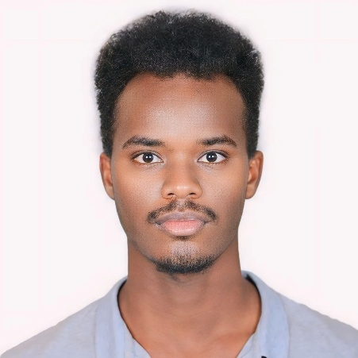

education
JIMMA UNIVERSITY / BSC IN SOFTWARE ENGINEERING
- 2022 - Present, Jimma, Ethiopia
- Expected graduation 2026

wORK EXPERIENCE
DIFFERENT COURSE PROJECTS
WEB DEVELOPMENT
- M-Market E-Commerce Website
- AI-Based Product Recommendation System
- Edir Management
- Rental Management System
JAVA PROJECT
- mp4 player
- Multi-client chat App
MACHINE LEARNING
Predicting student dropout rate
MOBILE APPLICATION DEVELOPMENT
- Attendance management
- Grade calculator
- Predicting student dropout rate
- Employee Management system

XYZ Company | Chennai, Tamil Nadu
Jan 2020 – Dec 2021
Ensured optimal network performance by proactively monitoring and troubleshooting diverse network components (routers, switches, firewalls, etc.), minimizing downtime and maintaining user productivity.

Languages
- OROMIFFA: Advanced
- Amharic: Proficient
- English: Proficient

Skills
- Languages: js, ts, PHP, java, C++, Python, HTML, CSS
- Frameworks & Libraries: React, Next.js, Flutter
- DB: MySQL, Mongo DB, Supabase

Gemeda TAmiru
Software developer
Highly motivated and results-oriented software developer with expertise in building and optimizing dynamic web applications. Proficient in front-end development using React and Next.js. Driven by a passion for tackling complex coding challenges, enhancing performance, fortifying security, and elevating user experience. Eager to collaborate on cutting-edge projects in web development and Mobile apps

cONTACT
 Phone
+251914363390
 Email
gemedatam@gmail.com
 Address
Addis Ababa, Ethiopia

hobbies
- Reading
- Games
- Volleyball

